LAB-1: Use of Single Table

- Creating Database:
Query: CREATE DATABASE LAB1;
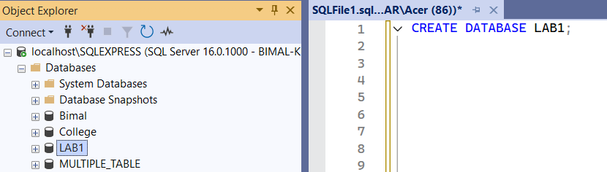

- Creating Table:
Query: CREATE TABLE STUDENT (
SID INT PRIMARY KEY,
SNAME VARCHAR(25),
GENDER CHAR(1),
AGE INT,
CLASS VARCHAR(20),
MARKS INT,
EMAIL VARCHAR(30),
ADDRESS VARCHAR(35)
);
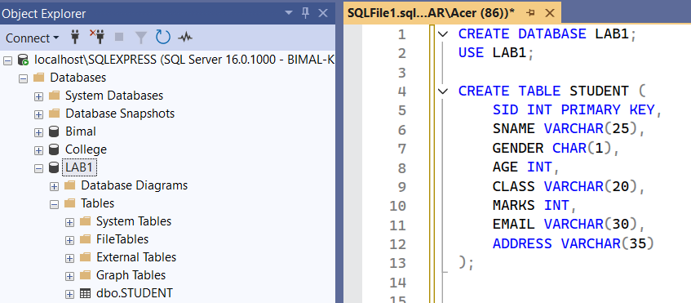

- Insert 15 students with full details including Email and Address.
Query : INSERT INTO STUDENT VALUES
(1, 'Bimal Kunwar','M', 19, '12A', 91, 'bimalkunwar@gmail.com', 'Kathmandu'),
(2, 'Rohit Sharma', 'M', 20, '12A', 88, 'rohit.sharma@gmail.com', 'Nagpur'),
(3, 'Virat Kohli', 'M', 20, '12A', 88, 'viratkohli@gmail.com', 'Mumbai'),
(4, 'Kane Williamson', 'M', 18, '12B', 90, 'williamson@gmail.com', 'Wellington'),
(5, 'Ben Stokes', 'M', 20, '12A', 85, 'bstokes@outlook.com', 'Manchester'),
(6, 'Smriti Mandhana', 'F', 18, '11A', 93, 'smriti.mandhana@gmail.com','Mumbai'),
(7, 'Ellyse Perry', 'F', 19, '11B', 65, 'ellyseperry@yahoo.com', 'Melbourne'),
(8, 'Harmanpr Kaur', 'F', 17, '11B', 84, 'harmanpreet.kaur@gmail.com', 'Mumbai'),
(9, 'Shubman Gill', 'M', 18, '11A', 78, NULL, 'Ahmedabad'),
(10, 'Jasprit Bumrah', 'M', 18, '12B', 82, 'bumrah@yahoo.com', 'Ahmedabad'),
(11, 'Rohit Sharma', 'M', 19, '11A', 88, 'rohit.sharma@gmail.com', 'Nagpur'),
(12, 'Mithali Raj', 'F', 20, '12A', 73, 'mithaliraj@rediff.com', 'Hyderabad'),
(13, 'Rashid Khan', 'M', 17, '11B', 90, 'rashidkhan@gmail.com', 'Kabul'),
(14, 'Meg Lanning', 'F', 19, '12B', 95, 'meglanning@yahoo.com', 'Melbourne'),
(15, 'Pat Cummins', 'M', 18, '11A', 88, 'cummins@gmail.com', 'Sydney');

- Display all student records with all columns.
Query: SELECT * FROM STUDENT;

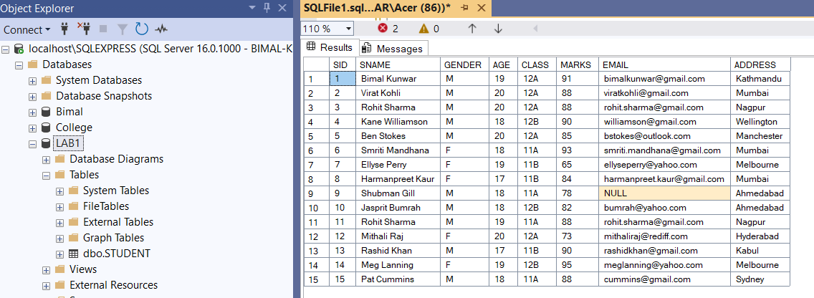

- Display only SName, Email, and Marks.
Query: SELECT SNAME, EMAIL, MARKS FROM STUDENT;
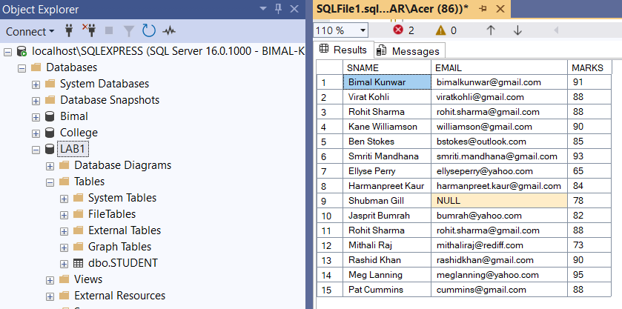

- Find students who live in a specific city (use LIKE on Address).
Query: SELECT * FROM STUDENT WHERE ADDRESS LIKE 'Mumbai';
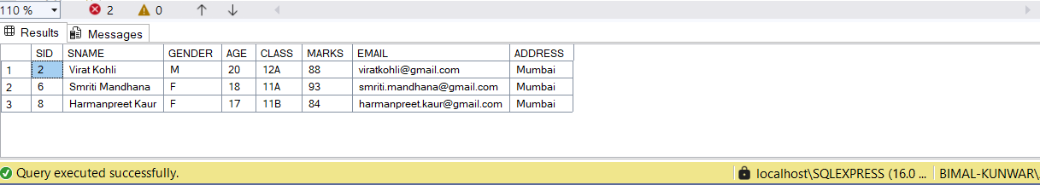

- Find students whose email ends with '@gmail.com'.
Query: SELECT * FROM STUDENT WHERE
EMAIL LIKE '%@gmail.com';
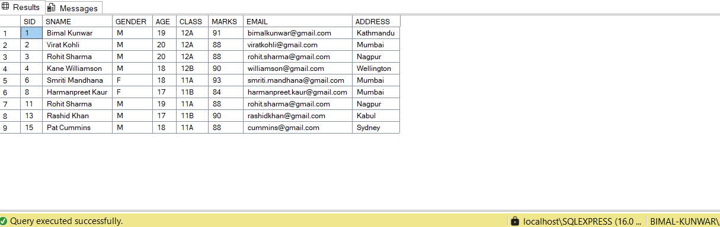

- Update the Address of a student with a specific StudentID.
Query: UPDATE STUDENT
SET ADDRESS = 'Banglore' WHERE SID = 2;
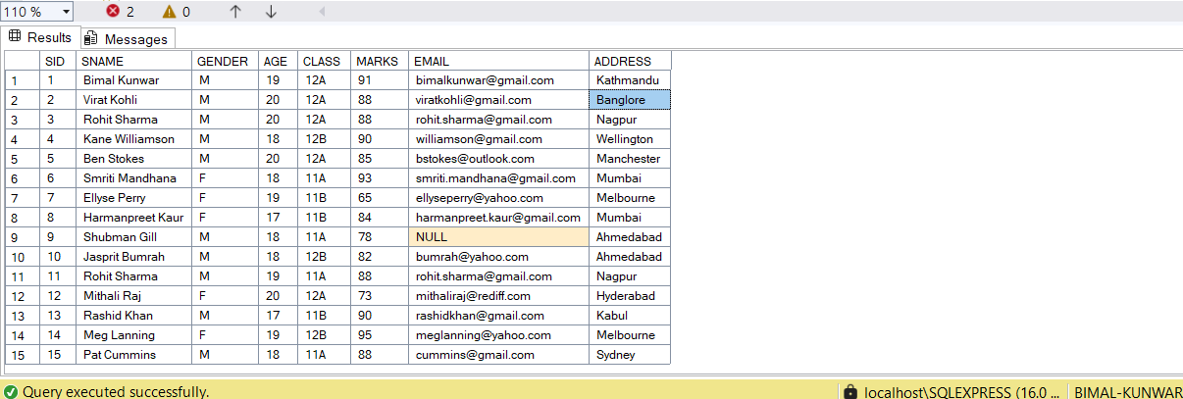

- List all students who scored more than 80 and are under 20 years old.
Query: SELECT * FROM STUDENT
WHERE MARKS > 80 AND AGE <= 20;
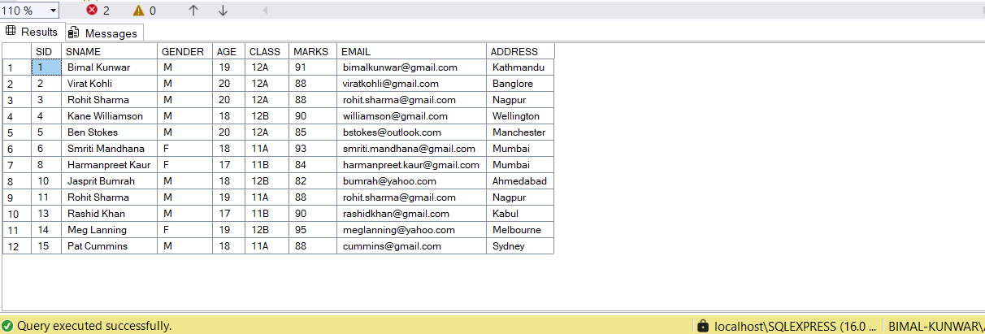

- Count how many students have email addresses from 'yahoo.com'.
Query: SELECT COUNT(*) FROM STUDENT
WHERE EMAIL LIKE '%@yahoo.com';

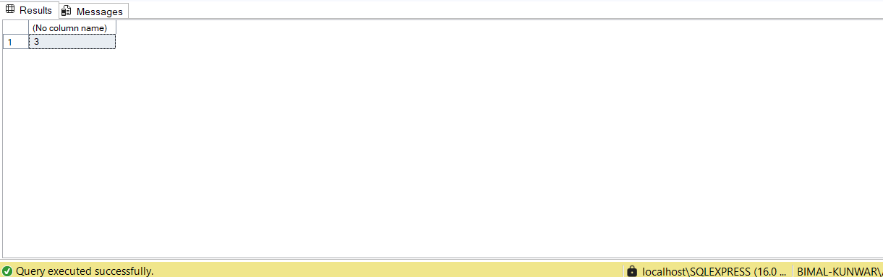

- Find students who have not provided an email (Email IS NULL).
Query: SELECT * FROM STUDENT WHERE EMAIL IS NULL;

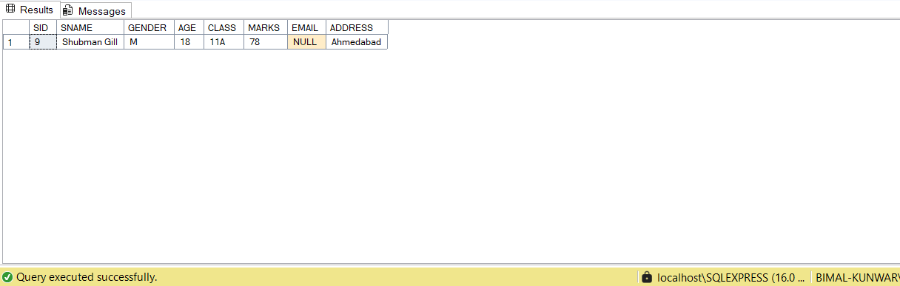

- Display all students ordered by SName alphabetically.
Query: SELECT * FROM STUDENT
ORDER BY SNAME ASC;
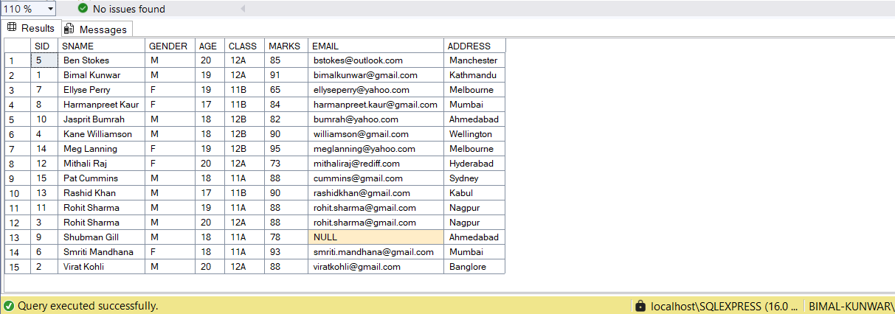

- Group students by Class and show the highest marks in each class
Query: SELECT CLASS, MAX(MARKS) AS
HIGHESTMARK FROM STUDENT GROUP BY CLASS;

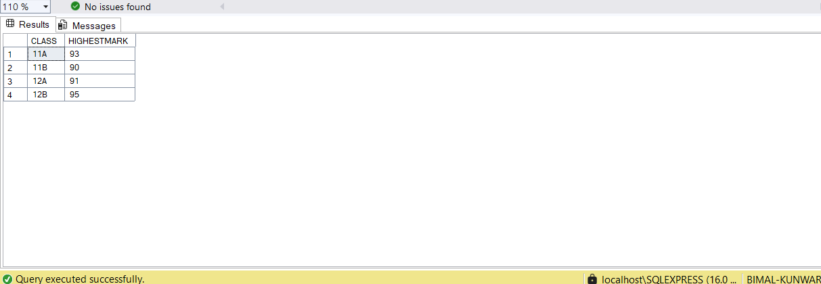

- Delete students whose address is 'NULL' or not specified.
Query: DELETE FROM STUDENT
WHERE ADDRESS IS NULL OR Address = '';

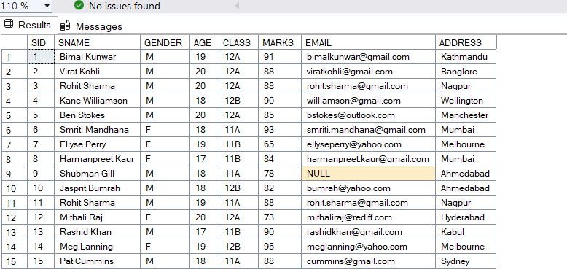

- Add a new column PhoneNumber to the student table.
Query: ALTER TABLE STUDENT
ADD PHONE VARCHAR(12);
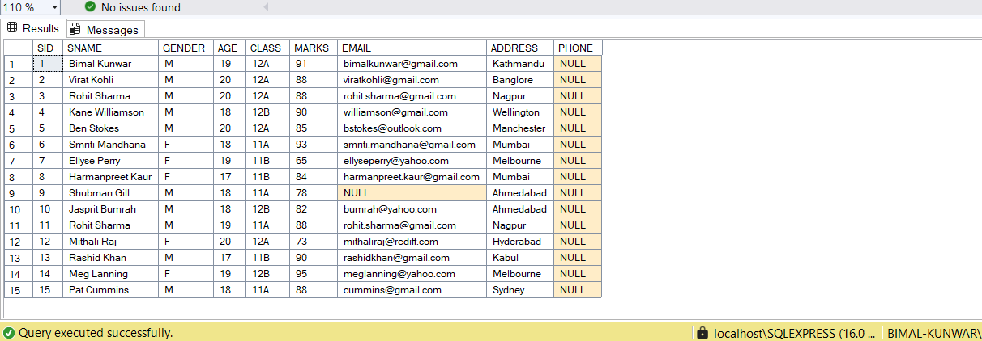

- Create a view ContactList to display SName, Email, and PhoneNumber.
Query: CREATE VIEW CONTACTLIST AS
SELECT SNAME, EMAIL, PHONE FROM STUDENT;
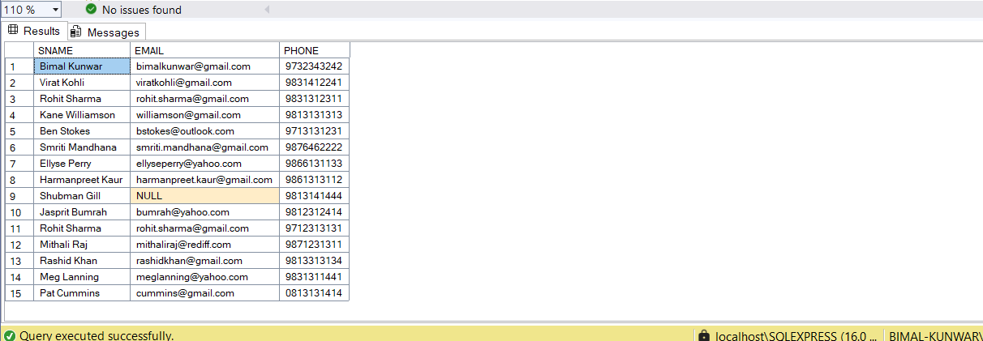

- Display students whose name starts with 'R' and ends with 'a'.
Query: SELECT * FROM STUDENT WHERE SNAME LIKE 'R%' AND SNAME LIKE '%a';

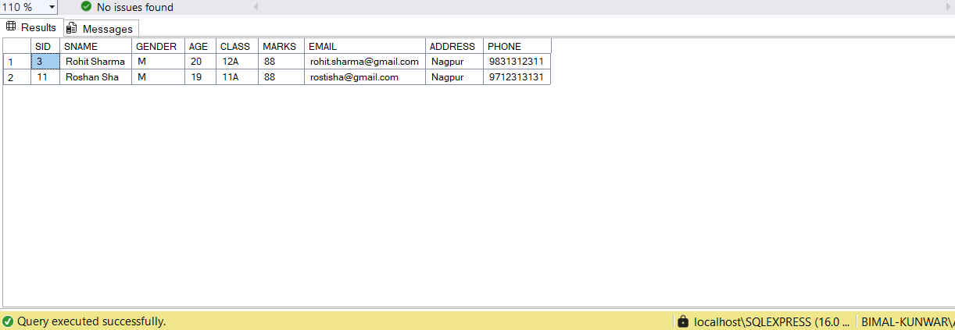

- Find the number of students per city (GROUP BY Address).
Query: SELECT ADDRESS AS CITY, COUNT(*) AS STUDENTCOUNT
FROM STUDENT
GROUP BY ADDRESS;
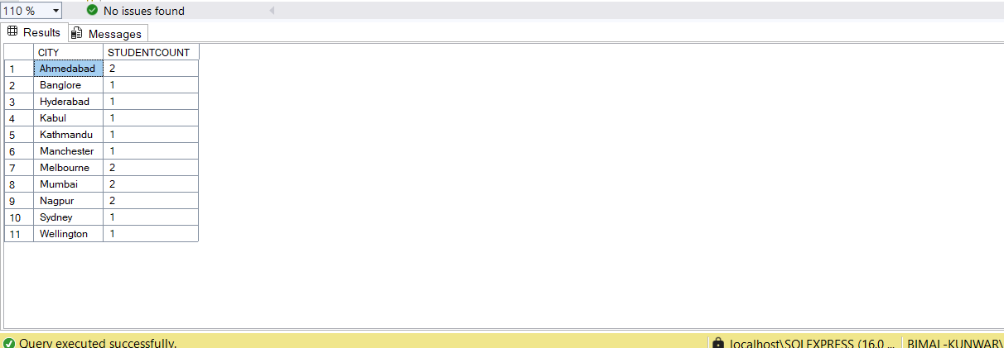

- Count how many male and female students exist (GROUP BY Gender).
Query: SELECT GENDER, COUNT(*) AS GENDERCOUNT
FROM STUDENT
GROUP BY GENDER;
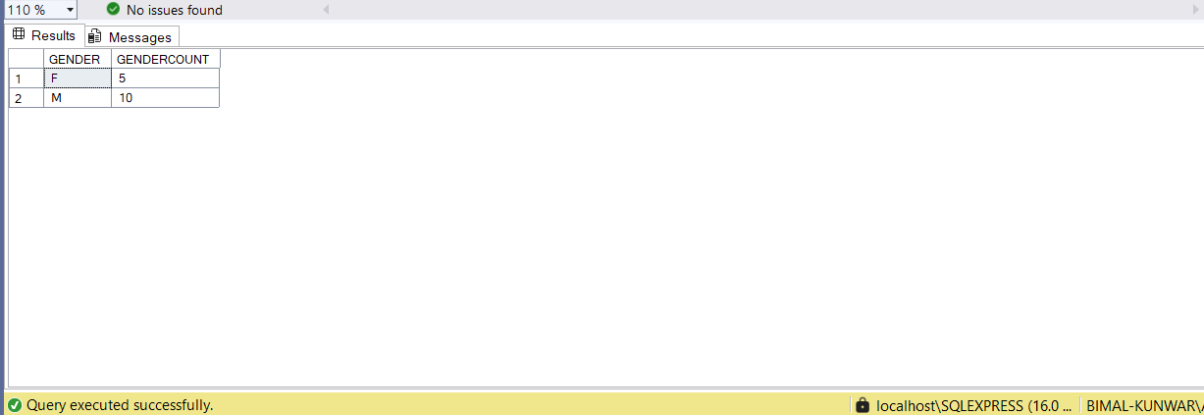

- Find students who have the same address but different names.
Query : SELECT * FROM STUDENT WHERE ADDRESS IN (
SELECT ADDRESS FROM STUDENT
GROUP BY ADDRESS
HAVING COUNT(DISTINCT SNAME) > 1
);
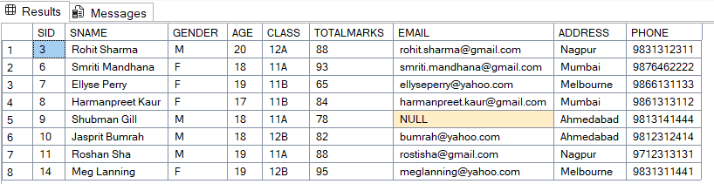

- Rename the column Marks to TotalMarks.
Query: EXEC sp_rename 'STUDENT.MARKS', 'TOTALMARKS', 'COLUMN';
